Technical & Financial Proposal
KHDMETI - Multi-Portal Service Booking Platform

Prepared by: RiseupLabs
Date: February 20, 2026

1. Introduction
This document provides a technical and financial proposal to develop the KHDMETI digital platform from scratch. The platform will enable users to discover and book services through web and mobile apps, while vendors manage bookings and operations via a web portal, and administrators oversee the full marketplace via a web-based super admin portal.
Key constraints for this proposal:
- Scope is limited to software development only (frontend, backend, database, integrations, DevOps, QA, documentation, and handover).
- Design and UI/UX are out of scope. Implementation will follow client-provided designs, branding, and UI specifications.
- Third-party licensing and usage fees (hosting, payment processor charges, SMS, push, analytics, maps, AI model usage, etc.) are excluded and will be billed directly to the client unless otherwise agreed.
- Any requirements beyond the agreed scope will be handled through a Change Request (CR) process.

2. Project Context & Objectives
KHDMETI is a service marketplace and booking platform with three primary surfaces:
- User Portal: Web + Mobile applications for discovery, booking, communication, payments, and account management.
- Vendor Portal: Web application for vendor operations including booking handling, staff management, calendar, and earnings.
- Super Admin Portal: Web application for platform administration, configuration, governance, analytics, and payouts.
Primary objectives include:
- Enable fast and reliable service discovery and booking with both manual and voice-based booking flows.
- Support end-to-end booking lifecycle management including reschedule, cancellation rules, refunds, and status tracking.
- Provide real-time communication between users and vendors per booking.
- Implement secure payments, wallet, commission calculation, and vendor payouts (including Stripe Connect onboarding and webhooks).
- Provide scalable administration capabilities (categories, dynamic form templates, fees, promotions, notifications, and reporting).
- Deliver production-ready non-functional requirements: security, performance, observability, and documentation.

3. Proposed Technical Approach & Methodology

3.1 Architecture Approach
We propose a modular, API-first architecture with clear separation between client applications and backend services. The solution will expose stable REST APIs and real-time WebSocket channels for chat and live booking updates. Location-based matching will be implemented using geo-capable database queries (PostGIS).
The system will include dedicated modules for Booking, Payments, Wallet, Commissions, Vendor Payouts, Notifications, Chat, and AI Voice Flow, each protected by role-based access controls.

3.2 Delivery Methodology
We will follow an iterative delivery model with milestone-based acceptance checkpoints.
- Backlog and acceptance criteria confirmed per milestone.
- Contract-first APIs: endpoints and request/response payloads agreed before implementation.
- Definition of Done per feature: implemented, tested, documented, and deployed to staging.
- Security-by-design: authentication, RBAC, audit logging, and OWASP-aligned practices.
- Quality assurance throughout: unit tests, integration tests, and regression testing prior to release.

3.3 Testing and Quality Assurance
- Unit tests for core domain logic (booking states, fee calculations, commissions).
- Integration tests for APIs, webhooks, and notifications.
- Real-time feature testing for chat and live status updates.
- Cross-device testing for mobile apps and responsive web apps.
- Security checklist verification (auth, RBAC, rate limiting, input validation).
- Performance and reliability checks for critical flows (checkout, webhooks, voice flow).

3.4 Environments, DevOps, and Governance
- Environments: Local, Staging, Production (separate configuration and secrets).
- Source control: Git repository with pull request based reviews and branch protections.
- CI/CD: automated build, lint, test, and deployment pipelines.
- Release governance: formal staging sign-off before production deployment.
- Operations baseline: monitoring, centralized logging, and error tracking.

4. Proposed Technical Stack
The stack below is selected to support the required feature set (real-time chat, geo-search, payments, multi-portal access, and AI voice flow) while remaining maintainable and scalable.
Layer | Proposed Choice
User Web Portal | Next.js (React) + TypeScript + Tailwind CSS
Mobile App | Flutter (Android + iOS) or React Native (final choice at kickoff)
Vendor Portal (Web) | Next.js (React) + TypeScript + Tailwind CSS
Super Admin Portal (Web) | Next.js (React) + TypeScript + Tailwind CSS
Backend API | Laravel
Real-time (Chat/Live Updates) | (WebSocket) + Redis
Async Jobs | Celery + Redis (emails, notifications, webhook processing, retries)
Database | MySQL
Object Storage (Media) | S3 compatible storage (AWS S3 or equivalent)
Payments | Stripe (Checkout, Webhooks, Stripe Connect onboarding and payouts)
Push Notifications | Firebase Cloud Messaging (FCM)
Maps/Geo | Google Maps or Mapbox (autocomplete, map view)
Analytics | Google Analytics
AI Voice Flow | Whisper or equivalent STT, LLM for intent and slot filling, template question engine, conversation state store
Observability | Sentry (errors), centralized logs, metrics dashboard (provider-based)
Security | JWT auth, TLS/SSL, rate limiting, WAF recommended, audit logging
API Documentation | OpenAPI/Swagger
Containerization | Docker

5. Scope of Work (Development Only)
The scope below is organized into seven (7) milestones to align delivery, testing, and acceptance. UI/UX design activities are excluded; development will implement client-approved designs.

5.1 Milestone Breakdown (7 Milestones)
Milestone | Key Scope (Feature Coverage) | Primary Deliverables
M1 - Inception & Core Foundation | Project setup, architecture, database baseline, environments, CI/CD, authentication and RBAC (Features: 1, 38). | Backend skeleton + DB schema/migrations, API baseline, role model (User/Vendor/Admin), staging environment, coding standards, initial QA plan.
M2 - User Discovery & Booking Creation | Browse/search services, category templates, manual booking, location/address, multi-service booking (Features: 2, 4, 5, 16, 17). | User web + mobile screens for discovery and booking form, dynamic input engine, saved addresses, core booking draft flow, APIs.
M3 - Booking Lifecycle, Chat, and Notifications | Vendor selection, booking management, cancellation/reschedule, chat, ratings, push + transactional emails (Features: 6, 9-13, 37). | Booking status engine, cancellation/refund rules support, WebSocket chat module, notification triggers for key events, rating and review module.
M4 - Vendor Portal MVP | Vendor dashboard, booking and service management, staff management, calendar, chat (Features: 18-23). | Vendor portal web app, vendor APIs, staff/availability module, calendar views, booking accept/reject and assignment, chat reuse.
M5 - Super Admin Portal MVP | Admin dashboards, vendor/user/booking management, category templates, platform coupons, cancellation rules, notification config (Features: 27-32, 35). | Admin portal web app, admin APIs, category and dynamic field template builder, coupon manager, rules configuration, admin audit logs baseline.
M6 - Payments, Wallet, Commission, and Payouts | Checkout, wallet, promo codes, revenue reports, Stripe Connect onboarding, payout management, payment webhooks, commission engine (Features: 7, 8, 15, 24, 33, 36, 42, 43). | Stripe integration (payments + webhooks), wallet ledger, commission calculation, vendor earnings and payout views, Stripe Connect onboarding flow, reconciliation logs.
M7 - Voice AI, Analytics, SEO, Deep Linking, and Go-Live | Voice booking flow, AI recommendations, vendor matching (geo), auto-assignment, analytics tracking, SEO, deep links, documentation/handover (Features: 3, 14, 39-41, 44-47, 34). | Voice assistant flow (STT + intent + slot filling), matching engine (radius + availability), analytics instrumentation, SEO baseline for web, mobile deep links, security/performance hardening, production release package.

5.2 User Portal Scope Summary (Web + Mobile)
User portal development will include (non-exhaustive):
- Onboarding and authentication: registration, login, email verification, password reset, JWT sessions.
- Service discovery: categories, search, featured services, location selector.
- Booking creation: manual form flow and dynamic category-specific inputs from admin templates.
- Voice-based booking flow: audio capture, speech-to-text, intent extraction, multi-turn slot filling and fallbacks.
- Booking lifecycle: active and past bookings, status tracking, cancellation and reschedule flows with fee rules.
- Payments and wallet: checkout, promo codes, wallet balance, refunds and transaction history.
- Communication and engagement: per-booking chat, push notifications, ratings and reviews, AI re-book suggestions.
- Location and address management: GPS, autocomplete, saved address CRUD, map view.
- Multi-service booking support within the same category.

5.3 Vendor Portal Scope Summary (Web Only)
Vendor portal development will include:
- Dashboard: booking statistics, schedule highlights, pending actions, earnings overview.
- Booking operations: view, filter, accept/reject, assign professionals, manage custom bookings.
- Service management: service catalog CRUD, pricing, category configuration, discounts.
- Professional and staff management: profiles, category assignment, availability, performance indicators.
- Calendar: schedule view with staff-based planning and rescheduling support.
- Chat: per-booking conversations with users using the shared chat backend.
- Revenue and payouts: earnings reports, payout history, and Stripe Connect status.
- Vendor coupons and referral tracking (where enabled by platform rules).

5.4 Super Admin Portal Scope Summary (Web Only)
Super admin portal development will include:
- Platform-wide dashboards and KPIs (users, bookings, revenue, conversion funnels).
- Vendor management: onboarding workflow, approvals, suspension, payout configuration.
- User management: view and manage user profiles and booking history.
- Booking management: global booking oversight, manual creation, overrides, assignment.
- Category and service configuration: manage categories and configure dynamic input templates.
- System coupons: platform-level coupon creation, usage statistics, enable/disable controls.
- Payout management: commission configuration, payout views, Stripe Connect onboarding status.
- Cancellation and reschedule rules: configurable conditions, thresholds, and fee policies.
- Notification trigger configuration: event toggles (email/push), basic template selection.

5.5 Essential Production Features
In addition to portal features, the delivery will include essential production requirements:
- Payment webhook processing for success/failure, disputes, and Connect payout events with retry and audit logs.
- Transactional email notifications for key booking and payout statuses.
- Role-based access control enforcement across APIs and portals.
- Radius-based vendor matching and professional auto-assignment based on availability and rating with override options.
- Commission engine to calculate platform fees and vendor net payouts.
- Analytics event tracking for booking funnel, voice usage, and referral sources.
- SEO baseline for the web portal: meta tags, Open Graph fields, JSON-LD, sitemap.xml, and robots.txt.
- Mobile deep linking: Universal Links (iOS) and App Links (Android) for shared booking URLs.
- Documentation and handover package: API docs, deployment runbook, and admin guide.

5.6 Human Resources and Responsibilities
The project will be executed by a cross-functional team. Final allocation may vary based on schedule and parallelization needs.
Role | Key Responsibilities
Project Manager | Planning, backlog management, acceptance criteria, stakeholder coordination, scope control, milestone sign-offs.
Tech Lead | Overall architecture, technical decisions, API standards, code review, performance and security oversight.
Backend developer(s) | PHP services, database schema, business logic, payments, webhooks, notifications, integrations.
Frontend Web developer(s) | User web, vendor portal, admin portal development, API integration, SEO, performance optimization.
Mobile App developer(s) | Flutter/React Native app development, API integration, push notifications, deep linking, release builds.
AI/ML Engineer (part-time) | Voice booking pipeline design, STT integration, intent extraction prompts/logic, conversation state and fallbacks.
QA Engineer | Test planning, functional testing, regression, API testing, real-time flows verification, release readiness checks.
DevOps Engineer | Environments, CI/CD, deployments, monitoring/logging setup, backups, operational runbook.

6. Deliverables
- User Portal: Production-ready Web app and Mobile app (Android + iOS) aligned to the approved designs.
- Vendor Portal: Production-ready Web portal for vendor operations.
- Super Admin Portal: Production-ready Web portal for full platform administration.
- Backend services and database with complete API layer, real-time chat services, and job processing.
- Payment, wallet, commission, and payout modules including Stripe webhooks and Stripe Connect onboarding.
- Voice AI booking module including conversation state management and fallbacks.
- Notification system (email and push) with configurable triggers and templates.
- Analytics instrumentation and reporting-ready event schema.
- CI/CD pipelines, staging and production deployments, and monitoring baseline.
- QA artifacts: test plan, test cases, defect tracking, and release readiness checklist.
- Documentation and handover: API documentation, deployment runbook, and admin operating guide.
- Knowledge transfer sessions and final source code handover.

7. Technical Diagrams (Placeholders)
Insert diagrams in the spaces below in the final version. Suggested diagram types are listed for clarity.

Diagram 1: High-Level Solution Architecture

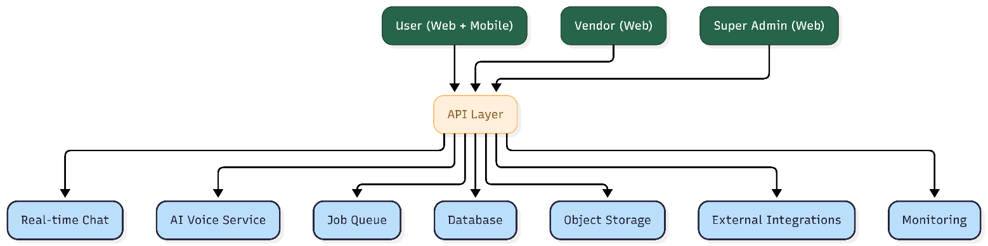

Diagram 2: Booking, Payment, and Payout Flow
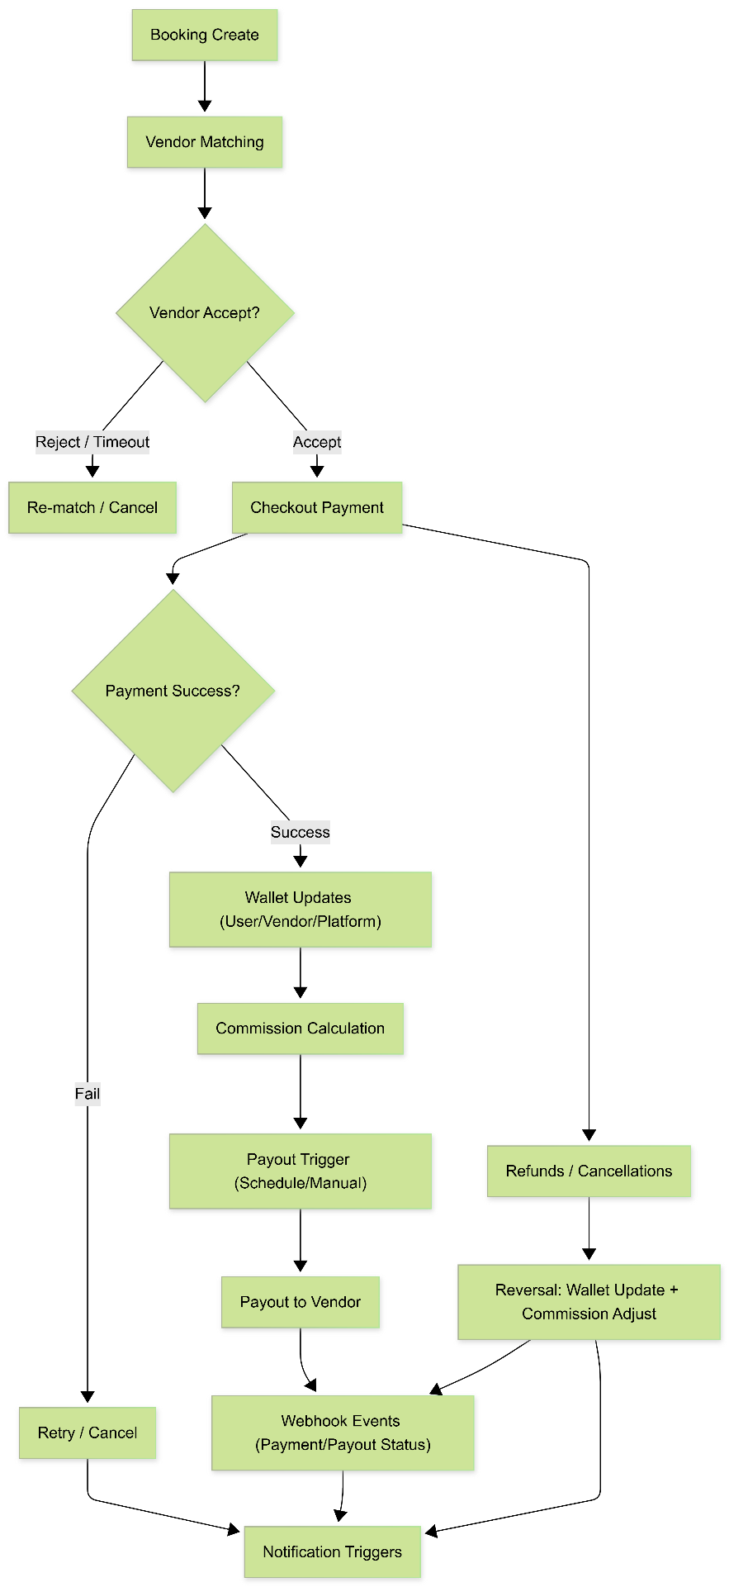

Diagram 3: CI/CD and Deployment Architecture
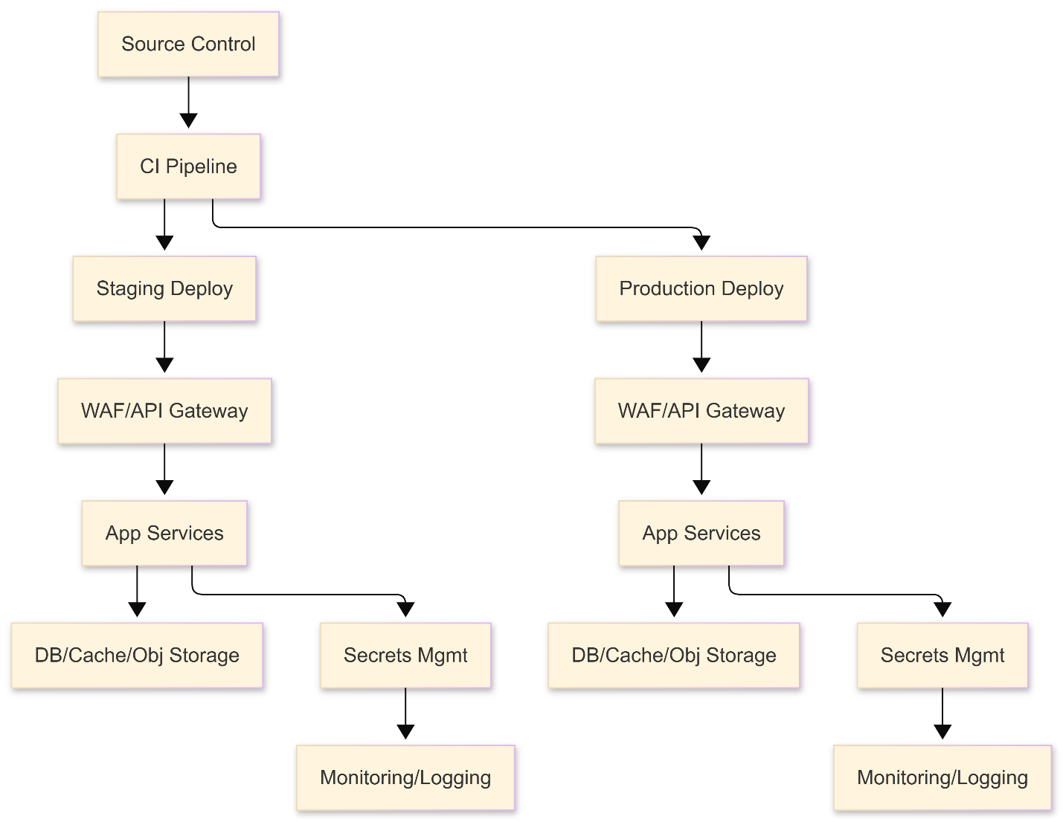

8. Complimentary Support (1 Month)
After production launch and final handover, we will provide one (1) month of complimentary support focused on the delivered scope.
Included:
- Bug fixing for reproducible issues introduced by the delivered work.
- Minor adjustments within existing UI patterns and configurations (small layout/copy/config changes).
- Support for analyzing logs and error reports where access is provided.
Excluded:
- New features or major enhancements beyond the agreed scope.
- Changes due to third-party provider policy changes or credential delays.
- Fixing pre-existing issues unrelated to the delivered modules.

9. Financial Proposal
The financial estimate below is based on the current feature breakdown and assumes development from scratch with the proposed stack. Final pricing may be adjusted after kickoff workshops and confirmation of third-party integrations, compliance constraints, and content/configuration details.
Phase | Working Team | Milestone | Estimated Duration | Estimated Cost (USD)
Phase 1 (6P) | 1 Project Manager  1 Tech Lead  1 Backend Developer  1 Mobile App Developer  1 Frontend Developer  1 QA Engineer | M1 - Inception & Core Foundation | 5 Weeks | $12,187
Phase 1 (6P) |  | M2 - User Discovery & Booking Creation | 5 Weeks | $12,187
Phase 1 (6P) |  | M3 - Booking Lifecycle, Chat, and Notifications | 5 Weeks | $12,187
Phase 2 (5P) | 1 Project Manager  1 Tech Lead  2 Backend Developer  2 Frontend Developer  1 QA | M4 - Vendor Portal MVP | 4 Weeks | $8,124
Phase 2 (5P) |  | M5 - Super Admin Portal MVP | 4 Weeks | $8,124
Phase 3 (11P) | 1 Project Manager  1 Tech Lead  2 Backend Developer  2 Mobile App Developer  2 Frontend Developer  1 AI Engineer  1 DevOps  1 QA Engineer | M6 - Payments, Wallet, Commission, and Payouts | 3 Weeks | $13,405
Phase 3 (11P) |  | M7 - Voice AI, Analytics, SEO, Deep Linking, and Go-Live | 3 Weeks | $13,405
Total |  |  | 12 weeks | $33,716

9.1 Payment Terms
Payment terms will be structured in three (3) terms as follows:
- 30% upfront upon project kickoff and contract signing.
- 30% at mid-completion upon acceptance of Milestone 4 (Vendor Portal MVP) on staging.
- 40% upon final delivery after acceptance of Milestone 7 and production release handover.
All payments are due within [X] business days of invoice issuance. Applicable taxes (if any) will be handled as per local regulations and contract terms.

9.2 Change Request (CR)
Any additional requirements beyond the agreed scope will be managed through a Change Request process.
- CR estimation will be provided as man-days and an updated timeline impact.
- Indicative CR rate: USD 150 per man-day or USD 25 per man-hour
- CR work will start only after written approval from the client.

9.3 Assumptions & Remarks
- Client will provide final UI designs and content requirements before relevant module development begins.
- Client will provide or create required third-party accounts and credentials (Stripe, FCM, Maps provider, analytics provider, AI provider).
- App store publishing fees and developer account fees are excluded and handled by the client.
- Platform policies (commission percentage, cancellation rules, refund policy, vendor onboarding requirements) will be confirmed during kickoff.
- AI model selection and usage limits will be finalized during kickoff; costs for model usage are excluded from this proposal.
- Timelines may shift if third-party credential approvals, compliance reviews, or domain/DNS changes are delayed.
- Data migration is not included unless explicitly defined (existing user/vendor/booking data sources are not provided in the current scope).

10. Proposed Out of Scope
- UI/UX design, branding, and creation of design assets.
- Content writing, translation services, or ongoing SEO content strategy.
- Third-party subscription fees (hosting, payment processing fees, SMS costs, map usage, analytics licensing, AI usage).
- Customer support operations, vendor onboarding operations, or call center operations.
- Any hardware procurement or device management for staff.

11. Acceptance & Sign-off
Delivery will be considered accepted when the agreed scope is implemented on staging, passes the QA and regression checklist, and is formally signed off by the client for the respective milestone. Production deployment will proceed after final sign-off and completion of the release checklist, followed by the one-month complimentary support period.

